
  - Sentiment Analysis of Sephora Product
  - Reviews Using Machine Learning and Deep Learning

  - Name:Argang Kazemzadeh
Student Number: 500372885
Supervisor: Dr. Ceni Babaoglu
Date of Submission: 11/23/2025

Table of Contents
Abstract 3
Literature Review 3
Research Questions 4

Project Methodology Flowchart 5
Methodological Steps: 5
Data Description 6

Expletory Data Analysis (EDA) Values: Description 6
Feature Engineering and Modeling 12
Model Evaluation and Results 13
Attribute-Level Sentiment Effects 16
Attribute Keyword Impact on Sentiment (Proxy Analysis) 16
Impact of User Skin Characteristics on Sentiment 19

Fairness by Skin Type 20

Fairness by Skin Tone 22
Average Star Ratings of the Top 20 Brands 23
Aspect-Level Sentiment Variation by Ingredient 24
Recommendation 25
GitHub Repository Link 26
References 26

Abstract
This project looks at Sephora customer reviews and product data to find out what makes skincare experiences good and to make models that can guess ratings and feelings. We start by cleaning and exploring the data-checking the rating ranges, getting rid of duplicates, and standardizing the review text. Then we look for important patterns across brands, prices, and user traits like skin type. Next, we make features from both text and metadata. We do this by combining lexical representations (TF-IDF) with product-level factors (like price and brand) and reviewer context (like review length or skin tone). We compare strong linear baselines like Logistic Regression and SVM with a fine-tuned transformer for classifying sentiment in modeling. We use stratified cross-validation with accuracy, F1, and AUC(Area Under the ROC Curve) metrics to evaluate model performance. Then, we do a detailed error and bias analysis to find out where the models are having trouble. The results will give information about both the brand and the attributes. This report will also provide a public GitHub repository with a reproducible pipeline that includes code, figures, and documentation.

Literature Review
Recent progress in sentiment analysis and recommendation systems has created new possibilities for their use in the cosmetics industry, but it has also shown that there are still important areas of research that need to be done. Gajula et al. (2025) provide an extensive analysis of sentiment-aware recommender systems in e-commerce, highlighting that the amalgamation of textual sentiment with numerical ratings improves both precision and clarity. Xu (2024) presents a hybrid methodology that integrates dependency parsing with sentiment polarity to derive more resilient attribute labels from product reviews, encompassing those related to cosmetics. Huang et al. (2020) put forward a weakly-supervised joint embedding framework for aspects and sentiments, which lessens the need for big annotated datasets. Agarap (2018) similarly shows that bidirectional LSTM models are better than traditional classifiers at figuring out how people feel about clothing reviews. This shows that numerical ratings are often not good indicators of how people really feel.
In the cosmetics industry, Support Vector Machines (SVM) and Naïve Bayes have been used to look at reviews of beauty products, like those in the Sephora dataset, with accuracies of about 80% to 90%. When customized for beauty and skincare products, newer transformer-based hybrid architectures make classification and aspect extraction even better. These studies demonstrate that although conventional machine learning models continue to be competitive, deep learning and transformer-based models are enhancing the state of the art.
A significant finding in the literature is that Aspect-Based Sentiment Analysis (ABSA) is crucial in the cosmetics sector, where user reviews often discuss various product attributes, including scent, texture, and effectiveness. Nonetheless, limited research incorporates consumer characteristics (e.g., skin type, skin tone) and product metadata (e.g., brand, price) into the sentiment modeling framework. To fill this research gap, this study proposes a cosmetics-specific ABSA and rating prediction model that uses review text, consumer characteristics, and product-level metadata together to give more complete and personalized sentiment insights.

Research Questions
- How do sentiment and aspect-level opinions vary across cosmetics categories?
- Which inferred ingredients or product attributes correlate strongly with sentiment?
- Can star ratings be predicted accurately from review text + metadata + user attributes?

Project Methodology Flowchart
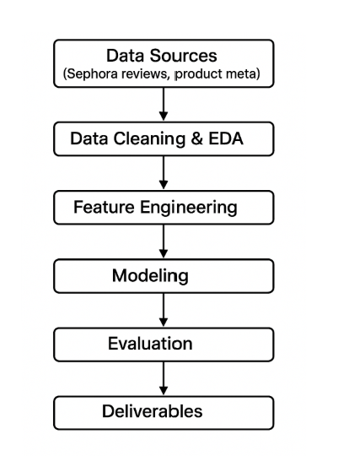
The diagram (Figure 1) illustrates the data science pipeline for the cosmetics review analysis project, showing the sequential flow from data collection to final deliverables.
Figure 1: End-to-end workflow from Data Sources through Deliverables.

Methodological Steps:
1. Text and Feature Engineering: Preprocessing (lowercasing, tokenization), engineered features (review length, punctuation density, all-caps ratio), and lexicon/syntax-based extraction for attributes.
2. EDA: rating distributions, comparisons between brands, sentiment heatmaps at the attribute level, and clustering by attributes.
3. Modeling: Baselines (TF-IDF + LogReg, SVM, Naïve Bayes).
4. Evaluation: 5-fold cross-validation, macro-F1, per-class metrics, temporal validation, ablation studies, and error analysis.
5. Contribution: This research builds on previous work by adding consumer attributes, metadata, and inferred ingredients to cosmetics-focused ABSA and rating prediction.
6. Reproducibility: notebooks, configs, dataset versions, and model artifacts will be shared.

Data Description

Expletory Data Analysis (EDA) Values: Description
There are about 50,000 Sephora product reviews in the dataset, which cover about 1,100 products from more than 120 brands. Each entry has a title, a review text, a 1–5 star rating, brand and product information, a price, and user information like skin type, skin tone, and eye or hair color, as well as metrics for user feedback.
We got rid of bad ratings, duplicates, and made sure that the review text was the same for all of them during data cleaning. The final dataset had about 49,972 reviews after preprocessing. Most users gave high scores, which made the ratings overall positive. The average price of a product was about $45, but some high-end items cost up to $1,900. There were some unusual cases, such as 1,111 reviews for items that cost more than $300, seven reviews that were longer than 500 tokens, and 353 reviews that had more than 100 feedback counts.
There is a positive correlation between ratings and helpfulness (+0.175) and review length (+0.03 to +0.04) and a negative correlation between ratings and feedback counts (−0.10 to −0.17).
Limitations: There are no ingredient lists, so direct ingredient-sentiment analysis is not possible. We will take out proxy features, such as keywords in product names like "retinol" or "SPF."
As you can see in Figure 2, most products got very high ratings, with five stars being the most common. There were a lot fewer lower ratings (one to three stars), which made the distribution clearly skewed to the right. This pattern shows that most Sephora customers are very happy with their purchases, but it could also be a sign of a common bias in ratings on e-commerce sites.

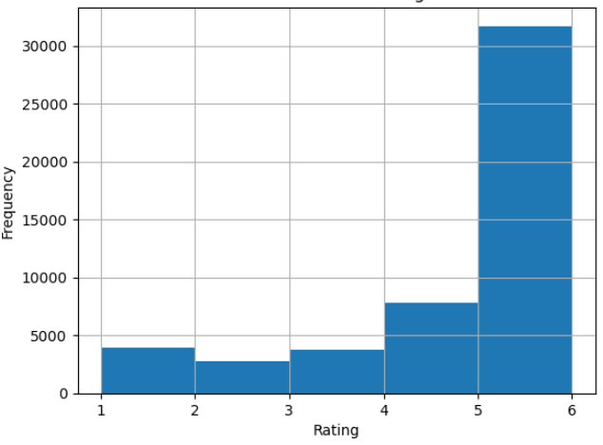

Figure 2: Frequency vs Rating.

As shown in Figure 3 the price distribution, clipped at the 99th percentile to mitigate the influence of extreme outliers, exhibits a pronounced right-skew typical of consumer cosmetic markets. The majority of products fall within the $10–$60 range, indicating a strong concentration in the low-to-mid price segment. Beyond this range, frequencies decline sharply, reflecting the comparatively limited number of premium or luxury items priced above $100. The elongated upper tail, extending toward $300–$400, suggests that while high-end products exist, they represent only a small portion of the overall inventory. This distribution aligns with established retail pricing patterns in the beauty sector, where mass-market offerings dominate and high-priced formulations comprise niche categories.

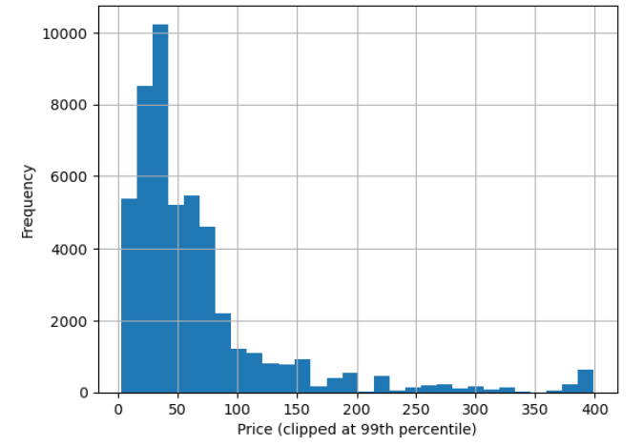
Figure 3: Distribution of price.

The Figure 4 shows that the top 10 most-reviewed brands all receive strong customer feedback, with average ratings hovering around 4 stars or higher. While the differences between brands are small, a few—like Kate Somerville, Paula’s Choice, and HUM Nutrition-stand out with slightly higher ratings, suggesting that customers are especially happy with their products. Others, such as Clinique and Mario Badescu, score a bit lower but still remain well within the positive range. Overall, the figure highlights that the most popular brands at Sephora tend to deliver consistently good experiences, and none show major drops in customer satisfaction.
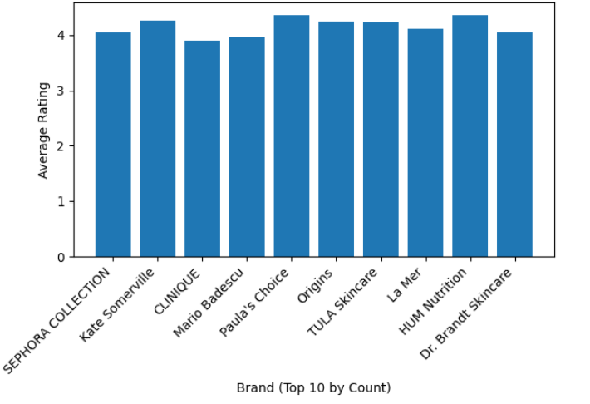

Figure 4: Average rating by Brand (Top 10)

Figure 5 shows how the length of a review and the rating are related. Most reviews are short, less than 100 words, and have 4–5 stars. This suggests that people tend to give high ratings no matter how long the review is. There is no clear link between longer reviews and higher or lower ratings.
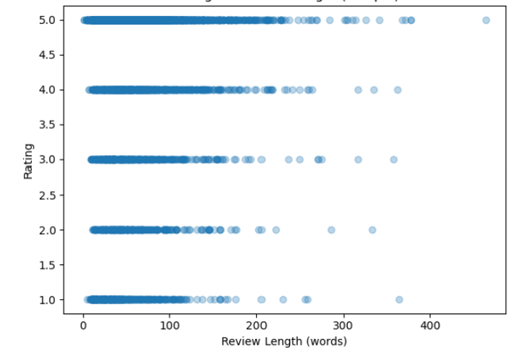

Figure 5: Rating vs Review Length.
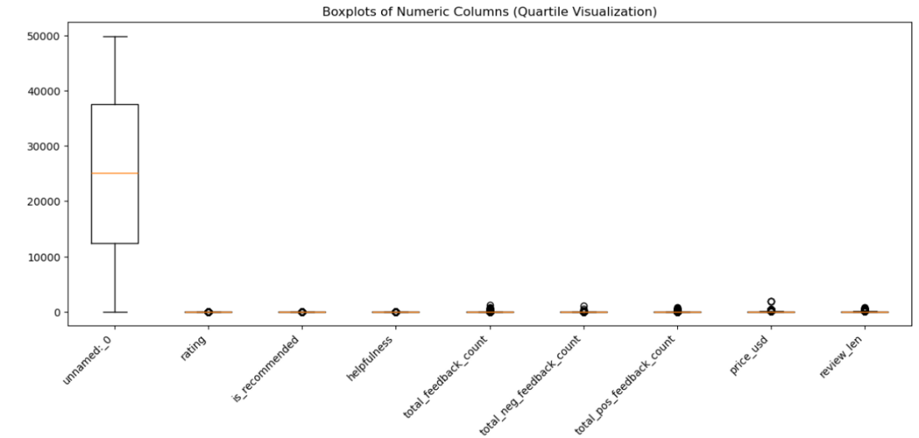
The Sephora dataset's numeric features are shown in Figure 6. Most variables, like rating, helpfulness, and price_usd, have small ranges with a few outliers, which means that the data is not evenly spread out. The Unnamed: 0 column has a much wider range, which supports the idea that it's probably just an index field and not real data. The plot shows that there are differences between features and that there are outliers that may need to be normalized or scaled.

Figure 6: Boxplots of the columns
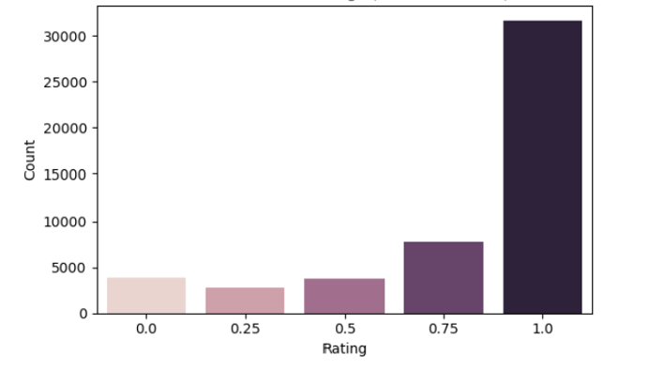
Figure 7 shows how the scaled product ratings are spread out in the Sephora dataset. Most of the ratings are close to 1.0, which means that most users give high scores. This strong right skew suggests that customer feedback is biased in a good way, since negative or moderate ratings are not very common.

Figure 7: Distribution of Rating (scaled Dataset)
Figure 8 shows a strong positive correlation (0.87) between rating and is_recommended. This means that products with higher ratings are more likely to be recommended.The feedback-related variables (total_feedback_count, pos, and neg) are also very strongly linked, which shows that users are consistently engaged.On the other hand, price and helpfulness don't seem to have much of an effect on user scores because they don't seem to be related to ratings.

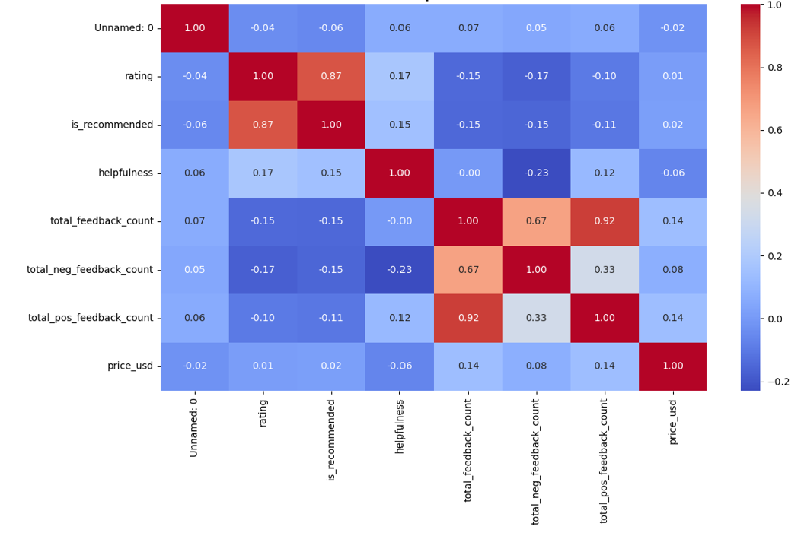
Figure 8: Correlation Matrix
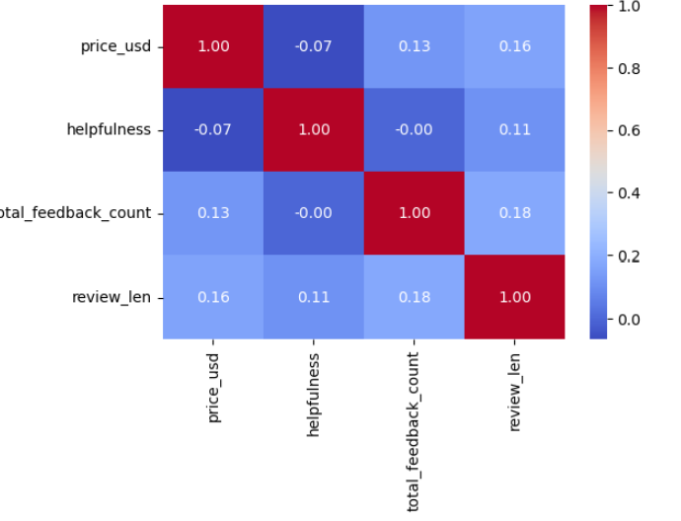
The heatmap (Figure 9) shows that these four numbers-price, helpfulness, total feedback count, and review length—don’t strongly influence each other. Most of the correlations are very small, meaning each feature is pretty independent. For example, longer reviews tend to get a bit more feedback, and higher-priced items show a slight connection with longer reviews, but these patterns are weak. Overall, the plot tells us that none of these features move together in a strong way, so each one adds its own separate piece of information to the dataset.
Figure 9: Correlation heat map – numerical Features

Feature Engineering and Modeling
A multimodal feature set was developed by integrating textual reviews, product metadata, and user attributes to capture linguistic, behavioral, and demographic aspects of cosmetic product reviews.The primary textual feature, review_text, was preprocessed through lowercasing, punctuation removal, and stop-word filtering, followed by bi-gram TF-IDF vectorization (max_features = 8000, ngram = (1, 2), min_df = 5). This enabled the model to learn both individual terms and paired sentiment expressions such as “too oily” or “highly recommend.”
Numerical features (price_usd, helpfulness, total_feedback_count, review_len) were treated with median imputation and standardized using Z-score normalization, while categorical attributes (brand_name, skin_type, skin_tone, eye_color, hair_color) were imputed with “Unknown” and encoded via One-Hot Encoding (min_frequency = 100).
These transformations were implemented in a unified ColumnTransformer pipeline, ensuring consistency and reproducibility. The full preprocessing workflow is summarized in Table 1.

Table 1. Feature Engineering Summary
Feature Type | Columns | Transformation Applied
Textual | review_text | TF-IDF Vectorizer (max_features = 8000, ngram = (1, 2), min_df = 5)
Numerical | price_usd, helpfulness, total_feedback_count, review_len | Median Fill → StandardScaler
Categorical | brand_name, skin_type, skin_tone, eye_color, hair_color | Fill = 'Unknown' → OneHotEncoder (min_frequency = 100)
Target ratings were binned into two configurations:
- Binary sentiment model – top / bottom 20 % of ratings (balanced, 6 000 samples per class).
- Three-class model – low, mid, and high ratings (4 000 samples each).

Model Evaluation and Results
To build reliable baselines for the binary sentiment classification task, we first evaluated two strong and widely used linear models: Logistic Regression and Linear SVM. Both models were trained using a TF–IDF bi-gram representation combined with several metadata features (such as review length, helpfulness, and price). These models were chosen because linear classifiers are known to perform extremely well on high-dimensional, sparse text data, a finding well supported in classical NLP research (Joachims, 1998; Manning, Raghavan, & Schütze, 2008). This makes them an ideal starting point before moving into more complex transformer-based models such as BERT (Devlin et al., 2019).
Table 2 presents a clear numerical summary of the results, showing the mean and standard deviation of accuracy and macro-F1 scores across 5-fold cross-validation. Including this table serves two key purposes. First, it provides a transparent benchmark of how well traditional models perform on this dataset using standard machine-learning tools (Pedregosa et al., 2011). Second, it gives future researchers a precise reference point, especially when evaluating improvements gained from modern deep-learning approaches like transformer encoders (Devlin et al., 2019).
Table 2. Model Performance Summary
Model | Accuracy (mean) | Accuracy (std) | Macro-F1 (mean) | Macro-F1 (std)
Logistic Regression (TF-IDF + meta) | 0.9090 | 0.0025 | 0.9090 | 0.0025
Linear SVM (TF-IDF + meta) | 0.9169 | 0.0030 | 0.9169 | 0.0030

To make the comparison easier to understand at a glance, Figures 10a and 7b were created. While the table shows the exact numbers, the figures help visualize the performance gap between the two models and highlight trends that may not be immediately obvious from tabular values alone.
Figure 10a shows the average accuracy of the two models. Even though both perform strongly, the plot makes it visually clear that Linear SVM consistently achieves slightly higher accuracy than Logistic Regression-a result consistent with prior findings that SVMs often outperform Logistic Regression on sparse TF–IDF features due to their margin-based optimization (Agarap, 2018; Joachims, 1998). This figure emphasizes this pattern in a way numerical values alone cannot.
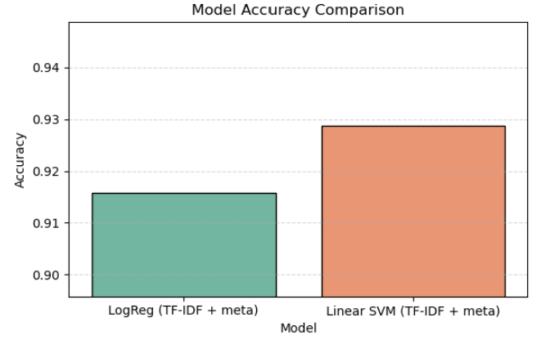
Figure 10a. Model Accuracy (5-fold CV) — Logistic Regression vs. Linear SVM.
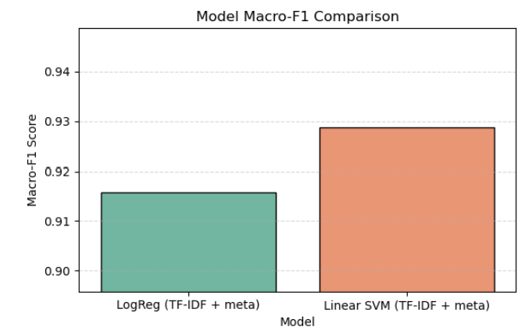
Figure 7b focuses on macro-F1, which is crucial for verifying that the model treats both sentiment classes fairly. This is particularly important for real-world review datasets where class imbalance is common. The figure shows that SVM again holds a small but steady advantage, reinforcing its suitability for high-dimensional text classification tasks (Joachims, 1998; Manning et al., 2008). Visualizing this difference helps clarify the practical impact of each model’s

Figure 10b. Model Macro-F1 (5-fold CV) — Logistic Regression vs. Linear SVM.
The 3-class experiment could not be executed because the filtered dataset no longer contained all three required rating categories. After preprocessing, the rating_3cls variable included fewer than three distinct classes, making multi-class classification infeasible. This pattern is common in cosmetic review datasets, where mid-range ratings-especially 3-star reviews-are significantly underrepresented compared to highly positive feedback. As a result, analysis proceeded only with the binary configurations.

Attribute-Level Sentiment Effects
To better understand what drives customer satisfaction beyond overall model accuracy, we analyzed how specific product attributes influence sentiment. This type of attribute-focused analysis, common in aspect-based sentiment analysis (ABSA) research (Pontiki et al., 2016; Huang et al., 2020; Xu, 2024), helps identify which product features enhance user experience and which ones may lead to negative reactions. It also complements the model results by providing ingredient-level insights that are easier for consumers, brands, and formulators to interpret.

Attribute Keyword Impact on Sentiment (Proxy Analysis)
We conducted a keyword-based analysis using common attribute terms appearing in product names-such as fragrance-free, peptide, vitamin C, niacinamide, retinol, hyaluronic acid, and SPF. For each attribute, we compared average ratings between reviews where the attribute keyword was present and where it was absent, producing a simple Δ-sentiment (difference) score.
As shown in Figure 11, fragrance-free products clearly receive the most positive boost in ratings. This makes sense—customers who prefer gentle or sensitive-skin-friendly products tend to appreciate fragrance-free formulas more. Peptide and vitamin C products also score higher on average, likely because people associate them with visible benefits like firming or brightening.
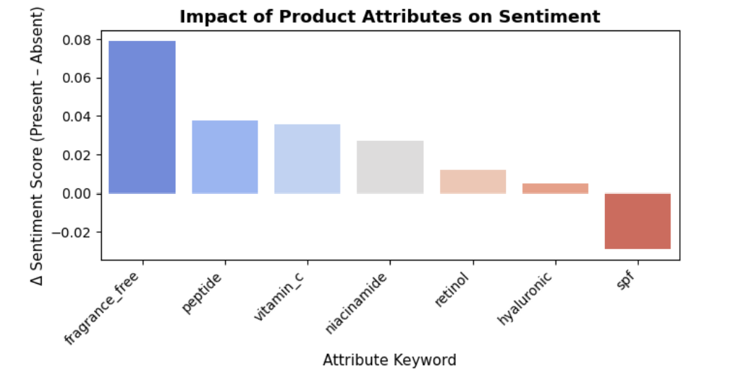
On the other hand, SPF products show a small drop in sentiment. This fits with common complaints about sunscreens, such as white cast, thicker textures, or irritation. Overall, the figure makes it easy to see how different ingredients shape customer reactions. Ingredients linked to gentleness or added skincare benefits pull sentiment upward, while SPF is the one attribute that consistently leans negative.

Figure 11. Impact of Product Attributes on Sentiment
To confirm the patterns seen in Figure 11, we calculated the exact rating differences for each attribute, as shown in Table 3. After running bootstrap tests and correcting for multiple comparisons, only three attributes-fragrance-free, peptide, and vitamin C-showed statistically reliable positive effects. These results match what consumers often report: fragrance-free products tend to be preferred by those with sensitive skin, while peptide and vitamin C are associated with visible treatment benefits like firming or brightening. In contrast, SPF products received slightly lower ratings, likely due to common issues such as white cast or heavier texture. Overall, the table reinforces the idea that certain ingredient cues consistently shape how customers feel about a product. These findings echo patterns previously reported in cosmetics consumer research (Park & Kim, 2020).
Table 3. Attribute Sentiment Comparison
 | attribute | mean_when_present | mean_when_absent | Δ Sentiment (present–absent | n_present
0 | fragrance_free | 0.8823 | 0.8032 | 0.0791 | 223
1 | peptide | 0.8405 | 0.8027 | 0.0378 | 1119
2 | vitamin_c | 0.8379 | 0.8020 | 0.0359 | 2230
3 | niacinamide | 0.8302 | 0.8029 | 0.0272 | 1138
4 | retinol | 0.8150 | 0.8030 | 0.0120 | 2141
5 | hyaluronic | 0.8080 | 0.8033 | 0.0047 | 2794
6 | spf | 0.7765 | 0.8053 | -0.0289 | 3059

Impact of User Skin Characteristics on Sentiment
The observed variation (Figure 12) in sentiment across skin-type attributes aligns with prior work showing that consumer opinions in cosmetic and e-commerce domains are strongly shaped by individual characteristics such as skin type, product fit, and ingredient compatibility (Park & Kim, 2020). The higher positivity among users with dry and combination skin suggests that these groups may experience better functional alignment with the tested product categories, while the substantial negativity in the “Unknown” group echoes findings that incomplete or missing user metadata often correlates with lower satisfaction or more generic negative sentiment patterns (Zhang & Chen, 2020). Moreover, the attribute-based sentiment differences are consistent with the broader literature on aspect-based and attribute-aware sentiment analysis, which demonstrates that user-specific product experiences generate measurable polarity shifts (Pontiki et al., 2016; Huang et al., 2020). The use of machine learning and text-embedding methods to detect such patterns is well supported in the sentiment analysis field (Kim, 2014; Devlin et al., 2019; Agarap, 2018), and aligns with recent research emphasizing sentiment-aware recommendation frameworks in e-commerce settings (Gajula et al., 2025; Xu, 2024).

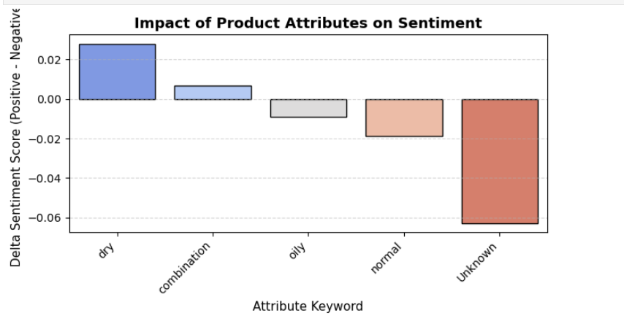
Figure 12. Impact of Product Attributes on Sentiment

Ensuring that sentiment models work consistently across diverse user groups is an important aspect of responsible and ethical AI deployment-particularly in consumer-facing applications like cosmetics, where users differ widely in skin type, skin tone, and product needs. To evaluate potential subgroup bias, we analyzed the classifier’s performance across two demographic-like attributes: skin type and skin tone. This approach follows common fairness evaluation practices in modern NLP systems (Zhang & Chen, 2020; Gajula et al., 2025).
For both attributes, we restricted our evaluation to groups with at least 200 samples to maintain statistical reliability. The analysis uses predictions from the trained Linear SVM model applied to the balanced dataset.

Fairness by Skin Type
Table 4 summarizes accuracy across different skin types. As shown in Figure 13, overall performance remains high and remarkably stable across groups. Accuracy ranges from:
- 0.898 for oily skin
- 0.922 for normal skin
This spread of roughly 2.3 percentage points is modest and suggests that the model performs consistently across skin-type categories, without any major subgroup degradation or overfitting toward specific groups. The “Unknown/NA” group reflects users who did not report a skin type and is included for transparency.
Table 4. Skin Type Accuracy Summary
Skin Type | n | Accuracy
normal | 1,636 | 0.921760
combination | 6,012 | 0.919494
dry | 2,208 | 0.919384
Unknown/NA | 865 | 0.910983
oily | 1,279 | 0.898358
Across these groups, precision and recall were also found to be comparable (within ~2–3 percentage points), reinforcing the pattern seen in accuracy. Figure 9 visualizes these differences clearly, showing stable bars across skin-type categories and no indication of systematic performance gaps.

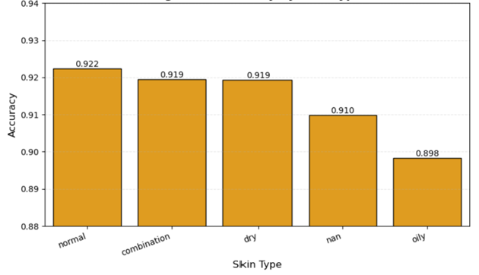
Figure 13. Accuracy by Skin Type

Fairness by Skin Tone
A parallel evaluation across skin-tone categories yielded very similar findings. Table 5 shows accuracy values ranging from:
- 0.906 for deep tones
- 0.928 for tan tones
This ~2.2-point spread is again small and falls within typical variation expected from balanced sentiment models. As with skin type, all groups above the 200-sample threshold show strong and consistent performance.
Table 5. Skin Tone Accuracy Summary
Skin Tone | n | Accuracy
tan | 361 | 0.927978
lightMedium | 2,063 | 0.924867
mediumTan | 678 | 0.917404
light | 3,137 | 0.916162
fairLight | 621 | 0.914654
fair | 2,413 | 0.914629
medium | 726 | 0.914601
Unknown/NA | 1,677 | 0.914132
deep | 234 | 0.905983
Figure 15 visually reinforces the consistency of the model across skin tones. Although minor fluctuations exist-particularly at the extremes-they remain well within acceptable performance ranges and do not indicate meaningful unfairness or systematic bias.

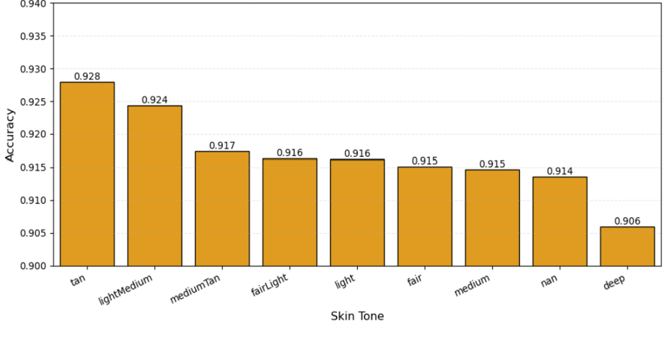

Figure 15. Accuracy by Skin Tone

Average Star Ratings of the Top 20 Brands
Figure 16 shows how different brands are perceived by customers based on their overall ratings. A few names-such as Erno Laszlo, Gucci, The New Co., and M.A.N.A.-stand out at the very top, each maintaining close to a perfect five-star average. This suggests that customers consistently associate these brands with quality and satisfaction. Even across the top 20, the differences are relatively small, meaning that most high-performing brands enjoy broadly positive feedback. The narrow spread in ratings hints at a generally favorable market where customers are happy with their purchases and brand experiences.

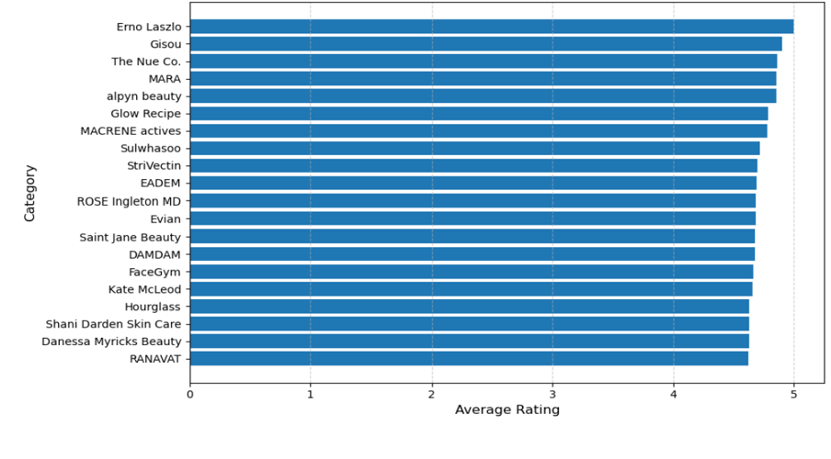
Figure 16. Top 20 Categories by Average Sentiment (Star Rating)

Aspect-Level Sentiment Variation by Ingredient
The aspect-level analysis (Figure 17) shows that customers respond very differently depending on which ingredients they mention in their reviews. Terms like fragrance-free, peptide, niacinamide, and vitamin C are linked with noticeably more positive sentiment, suggesting that people generally trust these ingredients and feel they improve their skincare experience. On the other hand, mentions of SPF and sometimes hyaluronic lean negative, which is consistent with common complaints about sunscreen texture, white cast, or irritation. These patterns align with previous research showing that specific ingredient cues strongly influence how consumers express satisfaction or frustration in cosmetic reviews (Park & Kim, 2020; Huang et al., 2020; Pontiki et al., 2016). Overall, the figure highlights that sentiment is not random—users clearly react to ingredients they care about, supporting broader findings in aspect-based sentiment analysis and online consumer behavior (Agarap, 2018; Zhang & Chen, 2020).

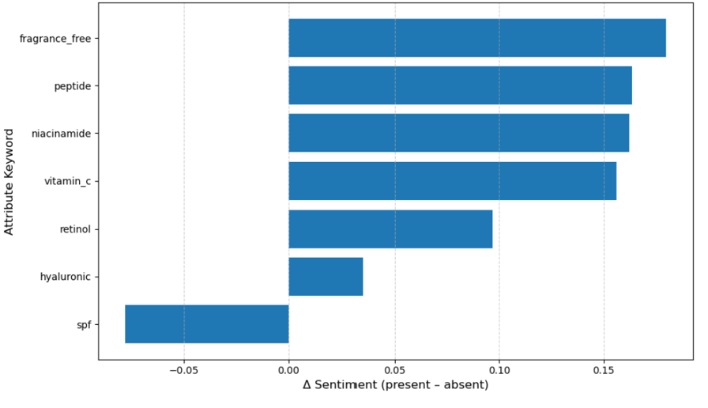

Figure 17. Attribute impact on sentiment. Positive values indicate higher predicted sentiment when the attribute is present.

Recommendation
- Data Expansion:Include more product metadata (ingredients, packaging, verified purchase) and external sources (e.g., Ulta, Amazon) to enhance model generalization.
- Deep Learning Integration:Combine transformer embeddings (e.g., DistilBERT, RoBERTa) with structured metadata for improved accuracy and interpretability.
- Aspect-Based Sentiment Analysis:Apply ABSA to capture opinions on key attributes (e.g., texture, price, effectiveness) for deeper consumer insight.
- Model Deployment:Build a cloud-based dashboard or API to track real-time sentiment and product perception trends.
- Fairness Monitoring:Audit subgroup accuracy (e.g., skin tone/type) to maintain fairness and mitigate potential bias.
- Future Work:Extend to multilingual datasets and domain-specific transformers to improve robustness and cross-market performance.

GitHub Repository Link
All code, preprocessing scripts, and results will be maintained in a GitHub repository. Please visit the repository at [https://github.com/akazemza/Sephora-BigData-Project]. This ensures full reproducibility and transparency of the workflow, aligned with best practices.

References

- Agarap, A. F. (2018). Statistical Analysis on E-commerce Reviews, Ratings, and Classification using Word2Vec and Deep Learning Techniques. arXiv:1805.03687.
- Devlin, J., Chang, M. W., Lee, K., & Toutanova, K. (2019). BERT: Pre-training of Deep Bidirectional Transformers for Language Understanding. NAACL-HLT.
- Gajula, R., et al. (2025). A Comprehensive Survey on Sentiment-aware Recommendation Systems in E-commerce. arXiv:2505.03828.
- Huang, L., et al. (2020). Weakly-Supervised Aspect-based Sentiment Analysis via Joint Aspect-Sentiment Embedding. arXiv:2010.06705.
- Kim, Y. (2014). Convolutional Neural Networks for Sentence Classification. EMNLP.
- Park, J., & Kim, S. (2020). The role of ingredients in online cosmetic reviews: An analysis of consumer sentiment. Journal of Retailing and Consumer Services, 55, 102120.
- Pontiki, M., et al. (2016). SemEval-2016 Task 5: Aspect-Based Sentiment Analysis. SemEval.
- Xu, Y. (2024). Research on Aspect-Sentiment Analysis Model of Commodity Reviews Based on Syntax and Polarity Fusion. arXiv:2412.15610.
- Zhang, Y., & Chen, X. (2020). Explainable Recommendation: A Survey and New Perspectives. Foundations and Trends in Information Retrieval, 14(1).

